Core Character Attributes and Their Effects (Podstawowe Atrybuty i Ich Wpływ)
1.1. Strength (Siła)
1.2. Dexterity (Zręczność)
1.3. Vitality (Witalność)
1.4. Intelligence (Inteligencja - INT)
1.5. Mentality (Mentalność - MEN)
1.6. Luck (Szczęście - LUC)
1.7. Charisma (Charyzma - CHA)
2. Offensive Statistics (Statystyki Ofensywne)
3. Defensive Statistics (Statystyki Defensywne)
4. Other Statistics (Inne Statystyki)
5. Attribute-Based Attack and Resistance (Atak i Odporność Atrybutowa)
6. Combat Statistics (Statystyki Walki)
7. PvP and PvE Statistics (Statystyki PvP i PvE)
8. Social Statistics (Statystyki Społeczne)
8. Core Game Mechanics Calculations (Core Obliczeniowy Gry)
10. Database Model (Model Bazy Danych)

1. Core Character Attributes and Their Effects (Podstawowe Atrybuty i Ich Wpływ)
1.1. Strength (Siła)
- Description (Opis): The physical power of the character.
- Impact on Statistics (Wpływ na Statystyki):
  - Physical Damage (Obrażenia Fizyczne): Each point of Strength increases physical damage by 1.35.
  - Destruction (Destrukcja): Each point adds 0.07 to the Destruction statistic.
- Impact on Skills (Wpływ na Umiejętności):
  - Enhances the power of physical skills.
  - Improves the effectiveness of basic attacks and offensive abilities.
- Formulas (Formuły):
  - Physical Damage:
Physical Damage = P.Atk + (Strength × 1.35)
  - Destruction:
Destruction = Base Destruction + (Strength × 0.07)
- Example (Przykład):
  - If a character has 20 points in Strength:
    - Additional Damage: 20 × 1.35 = 27
    - Additional Destruction: 20 × 0.07 = 1.4

1.2. Dexterity (Zręczność)
- Description (Opis): Increases attack speed, accuracy, and critical hit chance.
- Impact on Statistics (Wpływ na Statystyki):
  - Physical Damage: Each point adds 0.4 to physical damage.
  - Precision (Precyzja): Each point adds 0.25 to the Precision statistic.
- Impact on Skills (Wpływ na Umiejętności):
  - Enhances the effectiveness of physical skills.
  - Increases attack speed and accuracy.
- Formulas (Formuły):
  - Physical Damage:
Physical Damage = P.Atk + (Dexterity × 0.4)
  - Precision:
Precision = Base Precision + (Dexterity × 0.25)
- Example (Przykład):
  - If a character has 20 points in Dexterity:
    - Additional Damage: 20 × 0.4 = 8
    - Additional Precision: 20 × 0.25 = 5
1.3. Vitality (Witalność)
- Description (Opis): Represents the character's health and endurance.
- Impact on Statistics (Wpływ na Statystyki):
  - Maximum HP: Each point adds 45 to HP.
  - HP Regeneration: Each point adds 1.35 HP every 5 seconds.
  - Physical Defense (Obrona Fizyczna): Each point adds 0.75 to P.Def.
  - Resistance to Critical Hits: Each point adds 0.15% resistance.
  - Healing Effectiveness: Each point adds 0.2% to the effectiveness of received healing.
- Impact on Skills (Wpływ na Umiejętności):
  - Enhances survival abilities.
  - Increases effectiveness of healing skills.
- Formulas (Formuły):
  - Maximum HP:
Max HP = Base HP + (Vitality × 45)
  - HP Regeneration:
HP Regen = Base Regen + (Vitality × 1.35)
  - Physical Defense:
P.Def = Base P.Def + (Vitality × 0.75)
  - Resistance to Critical Hits:
Crit Resistance = Base Resistance + (Vitality × 0.15%)
  - Healing Effectiveness:
Heal Effectiveness = Base Effectiveness + (Vitality × 0.2%)
- Example (Przykład):
  - If a character has 15 points in Vitality:
    - Max HP Increase: 15 × 45 = 675
    - HP Regen Increase: 15 × 1.35 = 20.25 HP per 5 seconds
    - P.Def Increase: 15 × 0.75 = 11.25
    - Crit Resistance Increase: 15 × 0.15% = 2.25%
    - Heal Effectiveness Increase: 15 × 0.2% = 3%
1.4. Intelligence (Inteligencja - INT)
- Description (Opis): Increases magical power and effectiveness of spells.
- Impact on Statistics (Wpływ na Statystyki):
  - Magical Attack (M.Atk): Each point adds to M.Atk.
  - Spell Effectiveness: Each point may increase the effectiveness of spells.
- Impact on Skills (Wpływ na Umiejętności):
  - Enhances damage and potency of magical abilities.
  - May reduce casting time.
- Formulas (Formuły):
  - Magical Attack:
M.Atk = Base M.Atk + (INT × Increment Value)
  - Spell Effectiveness:
Spell Effectiveness = Base Effectiveness + (INT × Percentage Increase)
- Example (Przykład):
  - If a character has 25 points in Intelligence, and each point adds 1.5 to M.Atk:
    - M.Atk Increase: 25 × 1.5 = 37.5
1.5. Mentality (Mentalność - MEN)
- Description (Opis): Improves magical defense and mana-related attributes.
- Impact on Statistics (Wpływ na Statystyki):
  - Maximum MP: Each point adds to MP.
  - MP Regeneration: Each point increases MP regen.
  - Magical Defense (M.Def): Each point increases M.Def.
- Impact on Skills (Wpływ na Umiejętności):
  - Enhances resistance to magical attacks.
  - Improves mana sustainability for casting spells.
- Formulas (Formuły):
  - Maximum MP:
Max MP = Base MP + (MEN × Increment Value)
  - MP Regeneration:
MP Regen = Base Regen + (MEN × Increment Value)
  - Magical Defense:
M.Def = Base M.Def + (MEN × Percentage Increase)
- Example (Przykład):
  - If a character has 20 points in Mentality, and each point adds 2 to MP:
    - Max MP Increase: 20 × 2 = 40
1.6. Luck (Szczęście - LUC)
- Description (Opis): Influences random positive events and drop rates.
- Impact on Statistics (Wpływ na Statystyki):
  - Critical Hit Chance: Each point may increase critical hit rate.
  - Drop Quality: Each point increases chance for rare item drops.
- Impact on Skills (Wpływ na Umiejętności):
  - May enhance skills that have random effects.
- Formulas (Formuły):
  - Critical Hit Chance:
Crit Chance = Base Chance + (LUC × Percentage Increase)
  - Rare Drop Chance:
Rare Drop Chance = Base Chance + (LUC × Percentage Increase)
- Example (Przykład):
  - If each point of Luck increases critical hit chance by 0.1%:
    - With 30 Luck, Crit Chance Increase: 30 × 0.1% = 3%
1.7. Charisma (Charyzma - CHA)
- Description (Opis): Affects social interactions and effectiveness of allies.
- Impact on Statistics (Wpływ na Statystyki):
  - NPC Relations: Each point may improve relationships with NPCs.
  - Ally Effectiveness: Each point enhances summoned creatures or companions.
- Impact on Skills (Wpływ na Umiejętności):
  - Improves skills related to summoning or controlling allies.
- Formulas (Formuły):
  - Ally Effectiveness:
Ally Effectiveness = Base Effectiveness + (CHA × Percentage Increase)
- Example (Przykład):
  - If each point of Charisma increases ally effectiveness by 0.5%:
    - With 20 Charisma, Ally Effectiveness Increase: 20 × 0.5% = 10%

2. Offensive Statistics (Statystyki Ofensywne)
2.1. Increased Damage to Rulers (Silny na Władców)
- Description (Opis): Increases damage dealt to Ruler-type enemies by a certain percentage.
- Mechanism (Mechanizm): Adds an additional percentage to base damage when attacking Rulers.
- Formulas (Formuły):
Total Damage = Base Damage + (Base Damage × Increased Damage to Rulers %)
- Example (Przykład):
  - With 100 base damage and 20% "Increased Damage to Rulers":
Total Damage = 100 + (100 × 20%) = 120 damage
2.2. Increased Damage to Statues (Silny na Posągi)
- Description (Opis): Increases damage against Statue-type enemies by a certain percentage.
- Mechanism (Mechanizm): Similar to "Increased Damage to Rulers" but applies to Statues.
2.3. Increased Damage in Specific Areas (Silny na Starożytnych)
- Description (Opis): Increases damage dealt during expeditions in specific locations.
- Formulas (Formuły):
Total Damage = Base Damage + (Base Damage × Increased Damage %)
2.4. Increased Damage to Humans (Silny na Ludzi)
- Description (Opis): Increases damage against human enemies by a certain percentage.
- Formulas (Formuły):
Total Damage = Base Damage + (Base Damage × Increased Damage to Humans %)
2.5. Precision (Precyzja)
- Description (Opis): Increases critical hit damage by a certain percentage.
- Impact on Statistics (Wpływ na Statystyki):
  - Critical Damage: Each point adds to critical damage percentage.
- Formulas (Formuły):
Critical Damage = Base Critical Damage + (Base Critical Damage × Precision %)
- Example (Przykład):
  - With 150 base critical damage and 30% Precision:
Critical Damage = 150 + (150 × 30%) = 195 damage
2.6. Destruction (Destrukcja)
- Description (Opis): Reduces the enemy's armor value by a certain percentage (up to 85%).
- Mechanism (Mechanizm): Decreases the effective physical defense of the enemy.
- Formulas (Formuły):
Effective Enemy Armor = Enemy Armor × (1 - Destruction %)
- Example (Przykład):
  - If the enemy's armor is 100 and you have 30% Destruction:
Effective Enemy Armor = 100 × (1 - 30%) = 70
2.7. Aggression (Napastliwość)
- Description (Opis): Deals additional damage equal to a percentage of the enemy's current HP.
- Formulas (Formuły):
Additional Damage = Enemy Current HP × Aggression %
Total Damage = Base Damage + Additional Damage
- Example (Przykład):
  - Enemy has 1000 HP, and you have 5% Aggression:
Additional Damage = 1000 × 5% = 50
2.8. Domination (Dominacja)
- Description (Opis): Increases damage to Rulers and enhances spell effects against them.
- Formulas (Formuły):
Total Damage = Base Damage + (Base Damage × Domination %)
2.9. Auto Attack Damage Bonus (Bonus do Obrażeń z Ataków Podstawowych)
- Description (Opis): Adds a fixed value to the damage of basic attacks.
- Formulas (Formuły):
Total Damage = Base Damage + Auto Attack Damage Bonus
2.10. Area-of-Effect Damage (Obrażenia Obszarowe - AOE Damage)
- Description (Opis): Increases the damage of area-of-effect attacks by a certain percentage.
- Formulas (Formuły):
AOE Damage = Base AOE Damage + (Base AOE Damage × AOE Damage %)
2.11. Physical Attack (Atak Fizyczny - P.Atk)
- Description (Opis): The base value of physical damage.
- Formulas (Formuły):
Physical Damage = P.Atk + Modifiers
2.12. Magical Attack (Atak Magiczny - M.Atk)
- Description (Opis): The base value of magical damage.
- Formulas (Formuły):
Magical Damage = M.Atk + Modifiers

3. Defensive Statistics (Statystyki Defensywne)
3.1. Resistance to Humans (Odporność na Ludzi)
- Description (Opis): Reduces damage received from "Human" type enemies by a specified percentage.
- Mechanism (Mechanizm): Negates "Increased Damage to Humans".
- Formulas (Formuły):
Damage Received = Base Damage - (Base Damage × Resistance to Humans %)
- Example (Przykład):
  - Receiving 100 damage from a human enemy with 20% Resistance:
Damage Received = 100 - (100 × 20%) = 80 damage
3.2. Resistance to Critical Damage (Odporność na Krytyczne)
- Description (Opis): Reduces additional damage from critical hits by a specified percentage.
- Mechanism (Mechanizm): Negates "Precision".
- Formulas (Formuły):
Critical Damage Received = Additional Critical Damage - (Additional Critical Damage × Resistance to Critical Damage %)
- Example (Przykład):
  - If additional critical damage is 50 and you have 40% Resistance:
Critical Damage Received = 50 - (50 × 40%) = 30 damage

3.3. Physical Resistance (Nieużyteczność)
- Description (Opis): Increases resistance to physical attacks, reducing damage received by a certain percentage.
- Formulas (Formuły):
Physical Damage Received = Physical Damage - (Physical Damage × Physical Resistance %)
- Example (Przykład):
  - With 25% Physical Resistance and receiving 200 physical damage:
Physical Damage Received = 200 - (200 × 25%) = 150 damage
3.4. Tenacity (Nieustępliwość)
- Description (Opis): Reduces the effect of Aggression, negating additional damage from it.
- Formulas (Formuły):
Aggression Damage Received = Aggression Damage - (Aggression Damage × Tenacity %)
- Example (Przykład):
  - If Aggression Damage is 50 and you have 50% Tenacity:
Aggression Damage Received = 50 - (50 × 50%) = 25 damage
3.5. Maximum HP % (Maksymalne HP %)
- Description (Opis): Increases the character's maximum health by a certain percentage.
- Formulas (Formuły):
Max HP = Base HP + (Base HP × Maximum HP %)
- Example (Przykład):
  - If Base HP is 1000 and you have 10% Maximum HP Increase:
Max HP = 1000 + (1000 × 10%) = 1100 HP

4. Other Statistics (Inne Statystyki)
4.1. Gold Bonus (Bonus Złota)
- Description (Opis): Increases chance to triple the amount of gold obtained from Rulers during maps and expeditions.
- Mechanism (Mechanizm): Upon defeating a Ruler, there's a percentage chance to receive triple gold.
- Formulas (Formuły):
  - Tripling Event Occurs:
Gold Amount = Base Gold + (Base Gold × 200%)
  - Chance for Tripling:
Chance = Gold Bonus %
- Example (Przykład):
  - With a 20% Gold Bonus:
    - 20% chance to receive triple gold when defeating a Ruler.
4.2. Kleptomancy (Kleptomancja)
- Description (Opis): Increases chance to acquire items from enemies by a specified percentage.
- Mechanism (Mechanizm): Adds a percentage to the base item drop chance.
- Formulas (Formuły):
Total Drop Chance = Base Drop Chance + (Base Drop Chance × Kleptomancy %)
- Example (Przykład):
  - Base drop chance is 5%, Kleptomancy is 50%:
Total Drop Chance = 5% + (5% × 50%) = 7.5%

4.3. Mining Power (Siła Wydobycia)
- Description (Opis): Increases damage dealt to ore deposits, improving mining efficiency.
- Formulas (Formuły):
Total Damage to Ore = Base Damage + Mining Power
- Example (Przykład):
  - Base damage is 10, Mining Power is 5:
Total Damage = 10 + 5 = 15 damage
4.4. Harvest (Żniwa)
- Description (Opis): Gives a chance to triple the resources gathered from plants.
- Mechanism (Mechanizm): Percentage chance to receive triple resources when harvesting.
- Formulas (Formuły):
  - Tripling Event Occurs:
Resource Amount = Base Amount + (Base Amount × 200%)
  - Chance for Tripling:
Chance = Harvest %
- Example (Przykład):
  - With 15% Harvest:
    - 15% chance to triple gathered resources.

5. Attribute-Based Attack and Resistance (Atak i Odporność Atrybutowa)
5.1. Attribute Attack (Atak Atrybutowy)
- Types (Typy):
  - Fire (Ogień), Water (Woda), Earth (Ziemia), Wind (Wiatr), Holy (Świętość), Dark (Ciemność)
- Description (Opis): Adds elemental damage to attacks.
- Formulas (Formuły):
Total Damage = Base Damage + Attribute Attack
5.2. Attribute Resistance (Odporność Atrybutowa)
- Types (Typy):
  - Fire Resistance (Odporność na Ogień), etc.
- Description (Opis): Reduces damage received from elemental attacks.
- Formulas (Formuły):
Damage Received = Damage - (Damage × Attribute Resistance %)
- Example (Przykład):
  - If you receive 100 fire damage and have 20% Fire Resistance:
Damage Received = 100 - (100 × 20%) = 80 damage

6. Combat Statistics (Statystyki Walki)
6.1. Physical Attack (Atak Fizyczny - P.Atk)
- Description (Opis): Base value for physical damage calculations.
- Formulas (Formuły):
Physical Damage = P.Atk + Modifiers
6.2. Magical Attack (Atak Magiczny - M.Atk)
- Description (Opis): Base value for magical damage calculations.
- Formulas (Formuły):
Magical Damage = M.Atk + Modifiers
6.3. Physical Defense (Obrona Fizyczna - P.Def)
- Description (Opis): Reduces physical damage received.
- Formulas (Formuły):
Damage Received = Incoming Damage - (P.Def × Reduction Coefficient)
6.4. Magical Defense (Obrona Magiczna - M.Def)
- Description (Opis): Reduces magical damage received.
- Formulas (Formuły):
Damage Received = Incoming Magic Damage - (M.Def × Reduction Coefficient)
6.5. Physical Accuracy (Dokładność Fizyczna - P. Accuracy)
- Description (Opis): Determines the precision of physical attacks.
- Formulas (Formuły):
Hit Chance = Base Chance + (P. Accuracy × Percentage Increase)
6.6. Physical Evasion (Unik Fizyczny - P. Evasion)
- Description (Opis): Increases chance to evade physical attacks.
- Formulas (Formuły):
Evade Chance = Base Chance + (P. Evasion × Percentage Increase)

7. PvP and PvE Statistics (Statystyki PvP i PvE)
7.1. PvP Physical Damage (PvP Fizyczne Obrażenia - PvP P. Dmg)
- Description (Opis): Reduces physical damage received from other players by a certain percentage.
- Formulas (Formuły):
PvP Physical Damage Received = Damage - (Damage × PvP P. Dmg %)
7.2. PvP Magical Damage (PvP Magiczne Obrażenia - PvP M. Dmg)
- Description (Opis): Reduces magical damage received from other players by a certain percentage.
- Formulas (Formuły):
PvP Magical Damage Received = Damage - (Damage × PvP M. Dmg %)
7.3. PvE Physical Damage (PvE Fizyczne Obrażenia - PvE P. Dmg)
- Description (Opis): Reduces physical damage received from monsters by a certain percentage.
- Formulas (Formuły):
PvE Physical Damage Received = Damage - (Damage × PvE P. Dmg %)
7.4. PvE Magical Damage (PvE Magiczne Obrażenia - PvE M. Dmg)
- Description (Opis): Reduces magical damage received from monsters by a certain percentage.
- Formulas (Formuły):
PvE Magical Damage Received = Damage - (Damage × PvE M. Dmg %)

8. Social Statistics (Statystyki Społeczne)
8.1. Reputation (Reputacja)
- Description (Opis): Influences interactions with NPCs and access to certain areas or missions.
- Mechanism (Mechanizm): Higher reputation may unlock special quests or discounts.
8.2. PvP/PK Points (Punkty PvP/PK)
- Description (Opis): Tracks the number of PvP engagements or player kills.
- Mechanism (Mechanizm): May affect player status or access to PvP-specific content.
8.3. Raid Points (Punkty Rajdowe)
- Description (Opis): Points earned for participating in raids.
- Mechanism (Mechanizm): Can be exchanged for rewards or used to unlock content.
8.4. Recommendations (Rekomendacje)
- Description (Opis): Ratings or endorsements from other players or NPCs.
- Mechanism (Mechanizm): Higher recommendations may improve reputation or unlock social features.

9. Core Game Mechanics Calculations (Core Obliczeniowy Gry)
9.1. General Damage Calculation
Steps:
- Calculate Base Damage:
Base Damage = P.Atk + Strength Bonus + Dexterity Bonus + Auto Attack Damage Bonus
- Apply Offensive Modifiers:
Modified Damage = Base Damage × (1 + Offensive Modifiers %)
- Calculate Effective Enemy Armor (Destruction):
Effective Armor = Enemy Armor × (1 - Destruction %)
- Calculate Damage After Armor:
Damage After Armor = Modified Damage - Effective Armor
- Apply Critical Hit (if applicable):
Critical Damage = Damage After Armor × (1 + Critical Damage Bonus %)
- Apply Enemy Resistances:
Final Damage = Damage × (1 - Enemy Resistance %)

Example Calculation:
- Given:
  - P.Atk: 150
  - Strength: 20
  - Dexterity: 15
  - Auto Attack Damage Bonus: 10
  - Offensive Modifiers: 25% Increased Damage to Humans
  - Destruction: 30%
  - Enemy Armor: 100
  - Enemy Resistance: 20%
- Calculations:
  - Strength and Dexterity Bonuses:
Strength Bonus = 20 × 1.35 = 27
Dexterity Bonus = 15 × 0.4 = 6
  - Base Damage:
Base Damage = 150 + 27 + 6 + 10 = 193
  - Apply Offensive Modifiers:
Modified Damage = 193 × (1 + 25%) = 241.25
  - Effective Armor:
Effective Armor = 100 × (1 - 30%) = 70
  - Damage After Armor:
Damage After Armor = 241.25 - 70 = 171.25
  - Final Damage:
Final Damage = 171.25 × (1 - 20%) = 137 damage

10. Database Model (Model Bazy Danych)
10.1. Overview
To efficiently manage and utilize game statistics, a well-structured database model is essential. Below is the proposed database schema, including tables, their fields, and relationships.
10.2. Tables and Fields
1. Attributes (Atrybuty)
- Fields:
  - AttributeID (Primary Key)
  - Name (e.g., Strength, Siła)
  - Description
  - EffectFormula (Formula for calculations)
  - BaseValue
2. Statistics (Statystyki)
- Fields:
  - StatisticID (Primary Key)
  - Name
  - Description
  - Category (Offensive, Defensive, Other)
  - Formula
  - RelatedAttributeID (Foreign Key to Attributes)

3. Characters (Postacie)
- Fields:
  - CharacterID (Primary Key)
  - Name
  - Level
  - Class
  - Race
  - Attributes (Linked via CharacterAttributes)
4. CharacterAttributes (AtrybutyPostaci)
- Fields:
  - CharacterAttributeID (Primary Key)
  - CharacterID (Foreign Key)
  - AttributeID (Foreign Key)
  - Value
5. Skills (Umiejętności)
- Fields:
  - SkillID (Primary Key)
  - Name
  - Description
  - Type (Active, Passive)
  - RequiredLevel
  - Statistics (Linked via SkillStatistics)

6. SkillStatistics (StatystykiUmiejętności)
- Fields:
  - SkillStatisticID (Primary Key)
  - SkillID (Foreign Key)
  - StatisticID (Foreign Key)
  - Value
7. Equipment (Wyposażenie)
- Fields:
  - EquipmentID (Primary Key)
  - Name
  - Type (Weapon, Armor)
  - RequiredLevel
  - Statistics (Linked via EquipmentStatistics)
8. EquipmentStatistics (StatystykiWyposażenia)
- Fields:
  - EquipmentStatisticID (Primary Key)
  - EquipmentID (Foreign Key)
  - StatisticID (Foreign Key)
  - Value
9. Enemies (Przeciwnicy)
- Fields:
  - EnemyID (Primary Key)
  - Name
  - Type (Human, Ruler)
  - Level
  - Attributes (Linked via EnemyAttributes)
10. EnemyAttributes (AtrybutyPrzeciwnika)
- Fields:
  - EnemyAttributeID (Primary Key)
  - EnemyID (Foreign Key)
  - AttributeID (Foreign Key)
  - Value
10.3. Relationships
- One-to-Many Relationships:
  - One Character has many CharacterAttributes.
  - One Skill has many SkillStatistics.
  - One Equipment has many EquipmentStatistics.
  - One Enemy has many EnemyAttributes.
- Many-to-Many Relationships:
  - Characters can have multiple skills (handled via a linking table if needed).
  - Equipment can be used by multiple characters (if applicable).
10.4. Implementation Notes
- Data Integrity:
  - Use foreign keys to maintain relationships between tables.
  - Implement constraints to ensure data validity.
- Scalability:
  - The model allows for easy addition of new attributes, statistics, skills, and equipment.
- No Redundancy:
  - Ensure that each piece of data is stored only once and referenced where needed.
- Indexes:
  - Create indexes on key fields to improve query performance.
10.5. Usage Scenarios
- Calculating Character Damage:
  - Retrieve character's attributes from CharacterAttributes.
  - Apply formulas from Attributes and Statistics tables.
  - Include modifiers from EquipmentStatistics and SkillStatistics.
- Skill Effects:
  - Use SkillStatistics to determine the impact of skills.
  - Apply relevant formulas from the Statistics table.
- Enemy Interactions:
  - Use EnemyAttributes to determine enemy strengths and weaknesses.
  - Calculate damage received and resistances.

Database Tables with Sample Data Entries
Legend:
- PK: Primary Key
- FK: Foreign Key

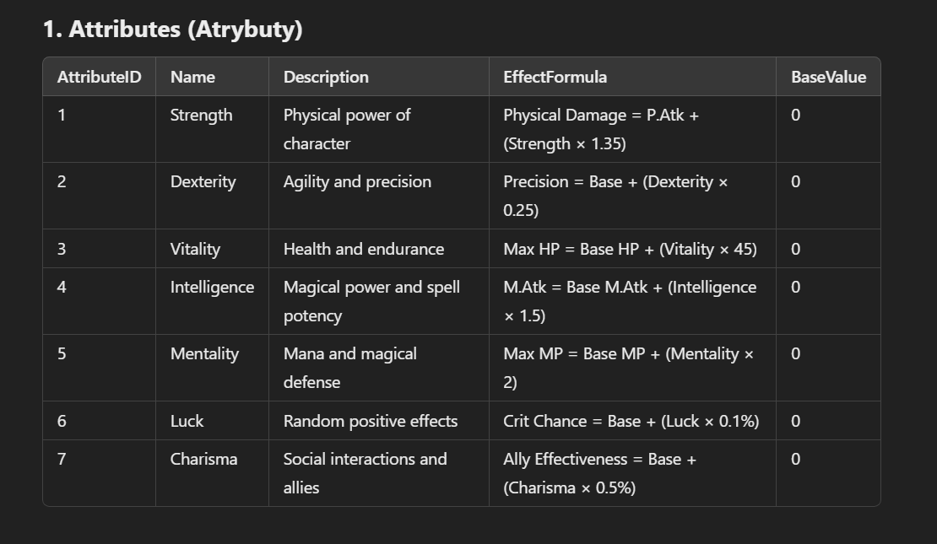
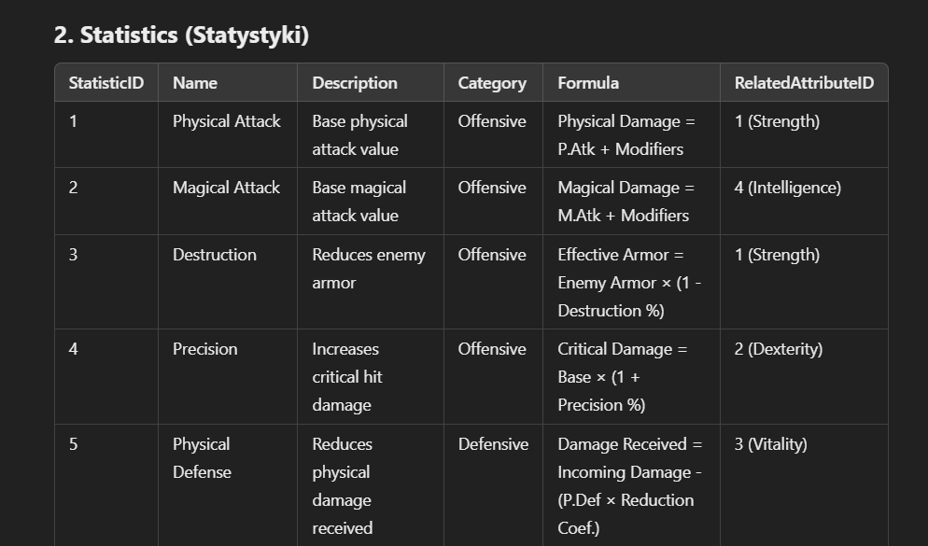
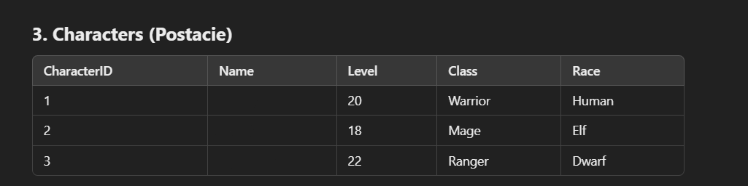
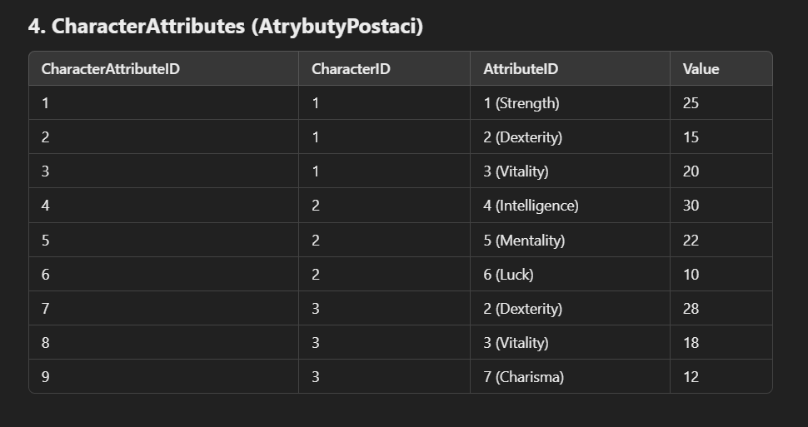
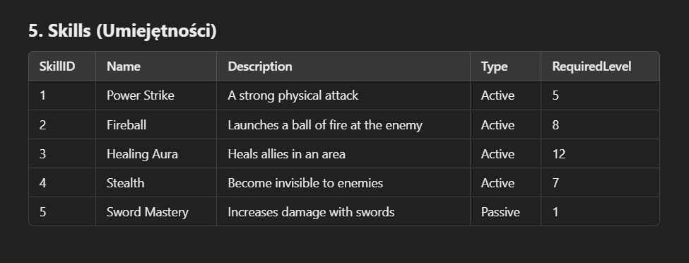
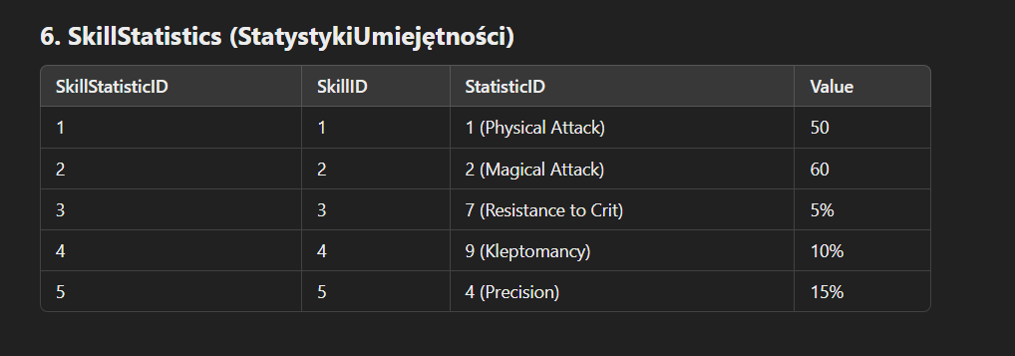
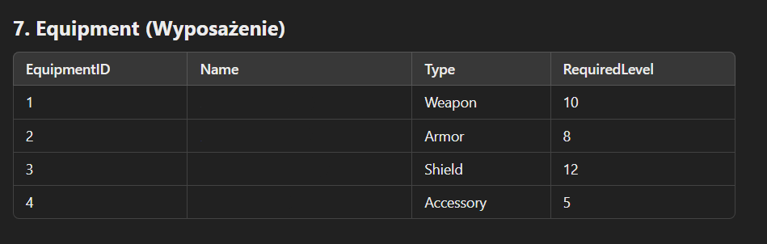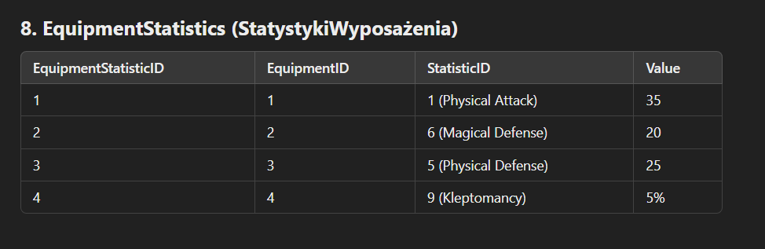
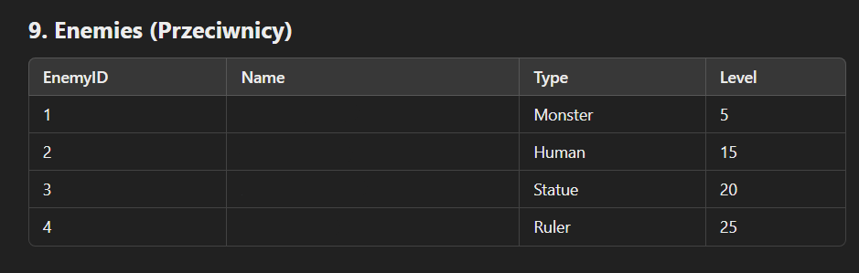
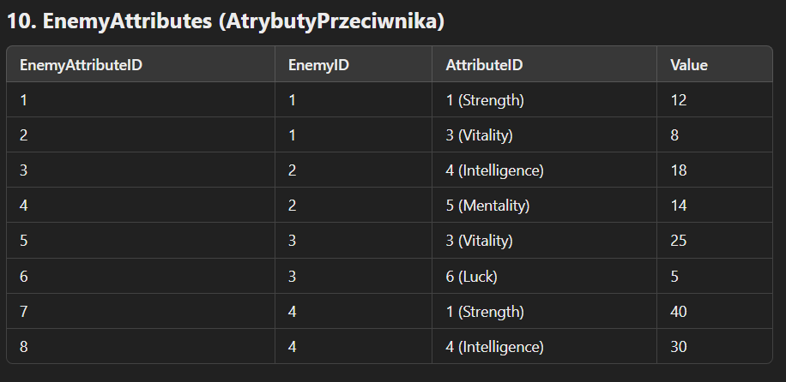
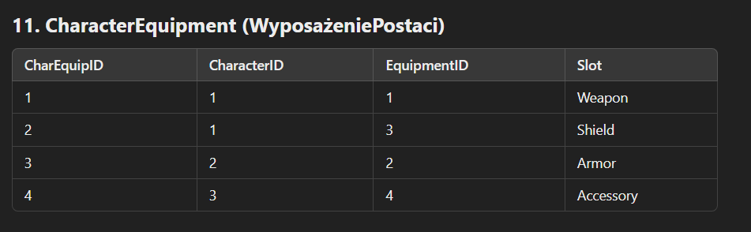
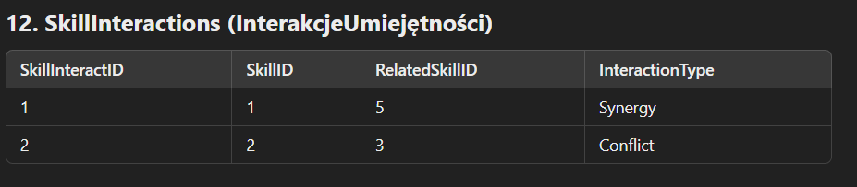

Descriptions of Relationships Between Tables
1. Characters and CharacterAttributes
- One-to-Many Relationship (Relacja Jeden-do-Wielu):
  - Explanation (Wyjaśnienie):
    - One character can have multiple attributes.
    - Each entry in CharacterAttributes links a character to a specific attribute and its value.
  - Example (Przykład):
    - CharacterID 1 (Arin) has attributes Strength (25), Dexterity (15), Vitality (20).
2. Attributes and Statistics
- One-to-Many Relationship:
  - Explanation:
    - Each statistic may be related to one attribute via RelatedAttributeID.
    - Attributes influence how statistics are calculated.
  - Example:
    - The statistic "Physical Attack" is related to the attribute "Strength".
3. Skills and SkillStatistics
- One-to-Many Relationship:
  - Explanation:
    - Each skill can have multiple statistics affecting its behavior.
    - SkillStatistics links a skill to its specific statistics and their values.
  - Example:
    - SkillID 1 (Power Strike) has a Physical Attack value of 50.
4. Equipment and EquipmentStatistics
- One-to-Many Relationship:
  - Explanation:
    - Each equipment item can have multiple statistics that define its effects.
    - EquipmentStatistics links equipment to its statistics.
  - Example:
    - EquipmentID 1 (Sword of Valor) increases Physical Attack by 35.
5. Characters and Equipment (via CharacterEquipment)
- Many-to-Many Relationship (Implemented via Linking Table):
  - Explanation:
    - Characters can equip multiple equipment items.
    - CharacterEquipment associates characters with the equipment they have equipped.
  - Example:
    - CharacterID 1 (Arin) has equipped EquipmentID 1 (Sword of Valor) in the Weapon slot and EquipmentID 3 (Shield of Fortitude) in the Shield slot.
6. Enemies and EnemyAttributes
- One-to-Many Relationship:
  - Explanation:
    - Each enemy has multiple attributes defining its capabilities.
    - EnemyAttributes links enemies to their attributes.
  - Example:
    - EnemyID 4 (Fire Dragon) has Strength 40 and Intelligence 30.
7. Skills and SkillInteractions
- Many-to-Many Relationship (Implemented via Linking Table):
  - Explanation:
    - Skills can interact with other skills through synergies or conflicts.
    - SkillInteractions defines how one skill affects another.
  - Example:
    - SkillID 1 (Power Strike) has a synergy with SkillID 5 (Sword Mastery).
8. Statistics and Attributes
- One-to-Many Relationship:
  - Explanation:
    - Statistics are influenced by attributes.
    - Each statistic may be associated with a related attribute via RelatedAttributeID.
  - Example:
    - The statistic "Destruction" is related to "Strength" and calculated using the character's Strength value.

Detailed Explanation of Relationships (Szczegółowe Wyjaśnienie Relacji)
Primary Keys and Foreign Keys
- Primary Key (PK):
  - A unique identifier for each record in a table.
- Foreign Key (FK):
  - A field in one table that uniquely identifies a record in another table, creating a link between the two tables.
Entity-Relationship Summary
- Characters (Postacie):
  - Related to CharacterAttributes:
    - CharacterID (PK) in Characters links to CharacterID (FK) in CharacterAttributes.
  - Related to CharacterEquipment:
    - CharacterID (PK) in Characters links to CharacterID (FK) in CharacterEquipment.
- Attributes (Atrybuty):
  - Related to CharacterAttributes:
    - AttributeID (PK) in Attributes links to AttributeID (FK) in CharacterAttributes.
  - Related to Statistics:
    - AttributeID (PK) in Attributes links to RelatedAttributeID (FK) in Statistics.
  - Related to EnemyAttributes:
    - AttributeID (PK) in Attributes links to AttributeID (FK) in EnemyAttributes.
- Statistics (Statystyki):
  - Related to SkillStatistics:
    - StatisticID (PK) in Statistics links to StatisticID (FK) in SkillStatistics.
  - Related to EquipmentStatistics:
    - StatisticID (PK) in Statistics links to StatisticID (FK) in EquipmentStatistics.
- Skills (Umiejętności):
  - Related to SkillStatistics:
    - SkillID (PK) in Skills links to SkillID (FK) in SkillStatistics.
  - Related to SkillInteractions:
    - SkillID (PK) in Skills links to SkillID and RelatedSkillID (FKs) in SkillInteractions.
- Equipment (Wyposażenie):
  - Related to EquipmentStatistics:
    - EquipmentID (PK) in Equipment links to EquipmentID (FK) in EquipmentStatistics.
  - Related to CharacterEquipment:
    - EquipmentID (PK) in Equipment links to EquipmentID (FK) in CharacterEquipment.
- Enemies (Przeciwnicy):
  - Related to EnemyAttributes:
    - EnemyID (PK) in Enemies links to EnemyID (FK) in EnemyAttributes.
Data Flow Example
- Calculating Character Damage:
  - Retrieve the character's attributes from CharacterAttributes based on CharacterID.
  - Use the EffectFormula from Attributes to calculate the base statistics.
  - Include modifiers from equipped items by retrieving equipment statistics from EquipmentStatistics via CharacterEquipment.
  - Apply any relevant skill statistics from SkillStatistics linked to the character's active skills.
- Applying Skill Effects:
  - When a skill is used, retrieve its statistics from SkillStatistics.
  - Apply any interactions with other skills using SkillInteractions.
  - Calculate the final effect using formulas from Statistics and associated attributes.
- Enemy Interaction:
  - Retrieve enemy attributes from EnemyAttributes.
  - Calculate enemy defenses and resistances using their attributes and relevant formulas from Statistics.
  - Determine damage dealt to the enemy by applying the character's calculated damage against the enemy's defenses.

2. System Przedmiotów i Ulepszeń

2.1 Kategorie Przedmiotów
- Broń: Dwuręczne miecze, jednoręczne miecze, łuki, różdżki, buławy itp.
- Pancerz: Hełm, rękawice, tors, spodnie, buty, tarcze, sigile.
- Biżuteria: Kolczyki (2), pierścienie (4), amulet (1).
- Dodatki: Peleryny, skrzydła, pasy, koszule, brooch z kamieniami szlachetnymi, bransolety z talizmanami, seedy, księga artefaktów.

2.2 Progresja i Ulepszanie Przedmiotów
- Poziomy Przedmiotów:
  - D -> C -> B -> A -> S -> Blessed S -> X -> X Lvl 1 -> X Lvl 2 -> X Lvl 3 -> X Dark Mode -> X Supreme Mode -> Legendary Set.
- Ulepszanie u Mistrza Kowalstwa:
  - Wymaga odpowiednich materiałów zdobywanych z Bossów, Riftów, górnictwa, zielarstwa itp.
  - Legendary Set: Dostępny tylko z Hell Mode Riftów, oferuje najlepsze bonusy i statystyki.

2.3 Modyfikacje i Personalizacja Przedmiotów
- Enchantowanie: Dodawanie zwojów zwiększających statystyki przedmiotu.
- Upgrading: Użycie kamieni ulepszenia do podniesienia podstawowych statystyk.
- Augmentacja: Dodawanie specjalnych efektów lub modyfikacji.
- Soul Crystals: Wprowadzanie kryształów dusz dodających dodatkowe wzmocnienia.
- Acumen: Personalizacja przedmiotów poprzez dodanie unikalnych efektów.
- System Elementów: Wzbogacanie przedmiotów o esencje żywiołów (ogień, zimno, ziemia, wiatr, ciemność), wpływające na różne aspekty walki.
- Personalizacja Statystyk: Możliwość dodania do 5 statystyk wybranych przez gracza; w przedmiotach Legendary możliwa jest szósta opcja.

3. System Umiejętności (Skilli)

3.1 Rodzaje Skilli
- Ofensywne: Zadające obrażenia przeciwnikom.
- Defensywne: Zwiększające obronę lub odporności.
- Wspomagające: Buffujące postać lub sojuszników.
- Inne: Specjalne umiejętności niepasujące do powyższych kategorii.

3.2 Skalowanie i Rozwój Skilli
- Skalowanie Statystyk: Umiejętności skalują się z odpowiednimi statystykami postaci (np. P.Atk, M.Atk).
- Poziomowanie u Trenera: Skille można podnosić na wyższe poziomy u trenera, zwiększając ich bazowe statystyki i zmieniając wygląd.
- Trenowanie przez Używanie: Częste używanie skilli prowadzi do ich naturalnego wzmocnienia i zmiany efektów graficznych.
- System Run: Ulepszanie skilli poprzez runy, które dodają nowe efekty i modyfikacje.

3.3 Enchantowanie i Ulepszanie Skilli
- Enchantowanie Skilli: Poprawa efektywności skilli poprzez wybór ścieżek rozwoju (np. zwiększenie siły, czasu trwania, obszaru działania).
- Drzewko Skilli Klasowych: Odblokowywanie dodatkowych efektów i zdolności poprzez zdobywanie poziomów i punktów umiejętności (od poziomu 40 do 80).
- Runy i Drzewka Rozwoju: Umożliwiają dalszą personalizację skilli i dodawanie unikalnych efektów.

4. System Subklas i Drzewka Rozwoju Postaci

4.1 Subklasy i Bonusy Statystyk
- Wybór Subklasy: Po osiągnięciu określonego poziomu gracze mogą wybrać subklasę, która daje dodatkowe pasywne umiejętności i bonusy do statystyk.
- Rozwój Statystyk:
  - Każdy poziom postaci dodaje podstawowe statystyki automatycznie, zależnie od klasy.
  - Dodatkowo, gracz otrzymuje 1 punkt statystyki na poziom do rozdysponowania według własnego uznania (np. siła, inteligencja, zręczność).

4.2 Drzewka Rozwoju i Ewolucja Klas
- Odblokowanie Drzewka:
  - Poziom 20: Pierwsze podniesienie klasy i odblokowanie drzewka rozwoju.
  - Poziomy 40, 60, 80: Kolejne ewolucje klasy, umożliwiające dalszy rozwój drzewka.
- Punkty Umiejętności:
  - Od poziomu 40 do 80, gracz otrzymuje 1 punkt umiejętności na poziom.
  - Dodatkowe punkty można zdobyć poprzez questy, osiągnięcia i system kolekcji.
- Personalizacja: Drzewka pozwalają na wybór specjalizacji i unikalnych zdolności, dostosowując postać do preferowanego stylu gry.

5. System Petów

5.1 Rozwój i Specjalizacja Petów
- Poziomowanie Peta:
  - Pet może osiągnąć poziom od 1 do 200.
  - Każdy poziom daje punkt umiejętności peta do rozdysponowania.
- Specjalizacje:
  - Agresja: Zwiększa P.Atk, M.Atk, moc umiejętności fizycznych i magicznych.
  - Obrońca: Zwiększa P.Def, M.Def, redukuje otrzymywane obrażenia z umiejętności.
  - Złotnik: Zwiększa pozyskiwane złoto.
  - Łowca: Zwiększa obrażenia przeciwko potworom.
  - Kolos: Zwiększa HP, MP, odporności na obrażenia krytyczne.
  - Oprawca: Zwiększa obrażenia w PvP, redukuje otrzymywane obrażenia w PvP.
  - Mądrość: Zwiększa szanse na pozyskanie przedmiotów z mobów.
  - Zwinność: Zwiększa szybkość ruchu, obrażenia krytyczne fizyczne i magiczne.
- Poziomy Umiejętności:
  - Maksymalnie 50 poziomów na umiejętność.
  - Pierwsze 25 poziomów można zdobyć za punkty umiejętności peta.
  - Poziomy 26-40 wymagają specjalnych ksiąg wzmocnienia peta.
  - Poziomy 41-50 wymagają arcymistrzowskich ksiąg peta (crafting).

5.2 Przedmioty dla Petów
- Sloty Przedmiotów:
  - Obroża Peta: Skupia się na statystykach ofensywnych.
  - Kolczyk Peta: Skupia się na statystykach defensywnych.
  - Pas Peta: Wpływa na inne statystyki.
  - Medalion Peta: Podnosi ogólną efektywność.
- Enchantowanie Przedmiotów:
  - Każdy przedmiot można enchantować do poziomu 200.
  - Enchantowanie dodaje bonusy i wzmacnia statystyki.

5.3 System Run dla Petów
- Odblokowanie:
  - Dostępny od poziomu 140 peta.
- Runy:
  - 8 run, każda z maksymalnym poziomem 150.
  - Runy wzmacniają procentowo 8 umiejętności peta.
- Tworzenie Run:
  - Wymaga alchemii i mieszania materiałów.
  - Proces mieszania determinuje poziom i efektywność runy.

6. System Tatuaży

6.1 Rodzaje Tatuaży
- Common Tatuaże:
  - Poziomy od 1 do 5.
  - Poziom 5 daje możliwość dodania 1-2 opcji modyfikacji.
- Epic Tatuaże:
  - Poziomy od 1 do 7.
  - Poziom 7 daje 3-4 opcje modyfikacji.
- Legendary Tatuaże:
  - Poziomy od 1 do 10.
  - Poziom 10 daje 5-6 opcji modyfikacji.

6.2 Bonusy i Personalizacja
- Maksymalna Ilość Tatuaży:
  - Gracz może nosić do 3 tatuaży jednocześnie.
- Bonusy:
  - Zwiększenie obrażeń, obrony, regeneracji many i HP.
  - Wzmocnienie innych statystyk według preferencji gracza.
- Personalizacja:
  - Tatuaże oferują wizualną personalizację postaci.
  - Wybór tatuaży pozwala dostosować postać do stylu gry.

7. Elemental Skills i System Kolekcji

7.1 Elementalne Umiejętności w Hellbound
- Esencje Żywiołów:
  - Fire Essence: Zwiększa obrażenia broni.
  - Cold Essence: Zwiększa P.Atk i M.Atk.
  - Earth Essence: Zwiększa HP i MP.
  - Wind Essence: Zwiększa obrażenia krytyczne.
  - Dark Essence: Zwiększa ogólne obrażenia.
- Poziomowanie:
  - Każdy żywioł ma 20 poziomów.
  - Zdobywanie esencji poprzez pokonywanie bossów i mobów w strefie Hellbound.

7.2 Tales of Hero
- Opis:
  - System zbierania specjalnych ksiąg opowiadających historię świata.
- Bonusy:
  - Zwiększenie statystyk obronnych: P.Def, M.Def, redukcja obrażeń krytycznych.
- Poziomowanie:
  - Od poziomu 1 do 450.
  - Każdy poziom daje nowe bonusy obronne.

7.3 System Kolekcji i Reliktów
- System Kolekcji:
  - Zbieranie unikalnych przedmiotów z mobów, bossów, profesji itp.
  - Oddawanie przedmiotów do różnych NPC w zamian za permanentne bonusy.
  - Posąg Światła: Główny mechanizm kolekcji, gdzie oddaje się paczki przedmiotów.
  - Legendarni Mistrzowie: NPC specjalizujący się w różnych profesjach (górnik, złodziej, zielarz itd.).
- Relikty:
  - Unikalne przedmioty wypadające z bossów i mobów powyżej D-Grade.
  - Można je przerobić na surowce lub użyć w systemie Relikt Kolekcji.
- System Badacza i Jubilera:
  - Oddawanie przedmiotów do badania w zamian za bonusy.
  - Badacz: Analizuje różne przedmioty, po określonej ilości daje permanentne statystyki.
  - Jubiler: Działa podobnie jak badacz, skupia się na biżuterii.
- System Artefaktów:
  - Oddawanie artefaktów do specjalnego NPC w celu zdobycia bonusów.
- Cel Systemu:
  - Zwiększenie motywacji do eksploracji i zbierania.
  - Umożliwienie graczom dalszego wzmacniania postaci poprzez różne aktywności.

